**Experiment No:7**

**Demonstration Of Heat Pump Trainer**

**Introduction:**

A heat pump is a device that transfers heat energy from a source of heat to what is called a [thermal reservoir](https://en.wikipedia.org/wiki/Thermal_reservoir). Heat pumps move [thermal energy](https://en.wikipedia.org/wiki/Thermal_energy) in the opposite direction of spontaneous [heat transfer](https://en.wikipedia.org/wiki/Heat_transfer), by absorbing heat from a cold space and releasing it to a warm space.

**Diagram:**

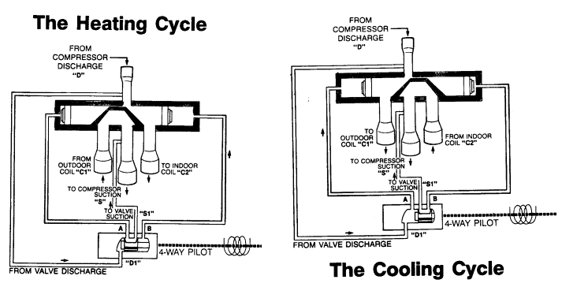

Fig no 7.1: Diagram of working cycle of heat pump

**Main Parts:**

 The most common design of a heat pump involves four main components;

* C[ondenser](https://en.wikipedia.org/wiki/Condenser_(heat_transfer))
* [Expansion valve](https://en.wikipedia.org/wiki/Thermal_expansion_valve)
* [Evaporator](https://en.wikipedia.org/wiki/Evaporator)
* [Compressor](https://en.wikipedia.org/wiki/Compressor)

The heat transfer medium circulated through these components is called [refrigerant](https://en.wikipedia.org/wiki/Refrigerant).

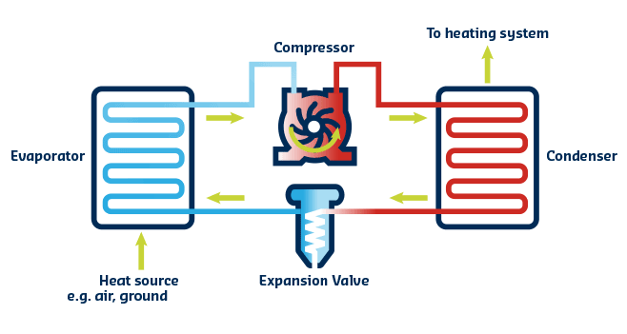

Fig no 7.2: Diagram of heat pump cycle

**Principle Working of Heat Pump Trainer :**

“Its operating principle is based on compression and expansion of a working fluid, or so called 'refrigerant'. A heat pump has four main components: evaporator, compressor, condenser and expansion device. In the condenser this heat is delivered to the consumer at a higher temperature level.”

Heat pumps move thermal energy in the opposite direction of spontaneous heat transfer, by absorbing heat from a cold space and releasing it to a warmer one. A heat pump uses external power to accomplish the work of transferring energy from the heat source to the heat sink.

**Heat Pump in Summer:**

During the summer, heat pumps work just like regular air conditioners. During the condensation process, the liquid refrigerant gives up its heat, which is radiated to the outside air as shown in fig(7.1). Now a cold, pressurized liquid, the refrigerant moves into the expansion valve, which restricts the flow of the liquid.

**Heat Pump in Winter:**

During the winter, heat pumps operate like an air conditioner in reverse. The refrigerant absorbs heat from the air outside and uses it to warm your home as shown in fig(7.1). In fact, most heat pumps can efficiently absorb heat from the air outside down to as cold as 20 degrees or lower.

**What temperature is not effective for a heat pump?**

 Heat pumps don't work well below 25-30 degrees Fahrenheit. But what you might not know is that the heat pump temperature range is broader than most people think, and with the addition of supplemental heating it can work even in the chilliest of temperatures.

**Will a heat pump work below zero?**

The short answer is yes, a heat pump will work in cold weather. But heat pumps only work efficiently if they have a backup heat source, like a gas furnace or electrical resistance coils.

**The Heating cycle of a heat pump:**

It works by taking heat in from air outside, warming it up further, and using this warm air to heat indoor air. It does so by the following process: Liquid refrigerant absorbs heat in the "evaporator" from the outdoor air, turning into a gas as shown in fig(7.3).

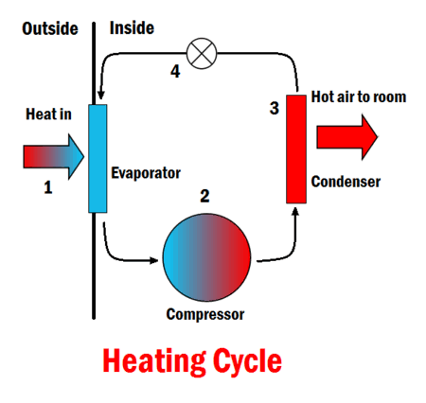

Fig no 7.3: Heating cycle of heat pump

**Cooling cycle of a heat pump:**

It is used to cool a space by removing **heat** from it and expelling it to another area, usually to the outdoors for **air conditioning** or to the room for a refrigerator. ... The cold refrigerant absorbs **heat** from the hotter room in the evaporator, so the room will cool down.

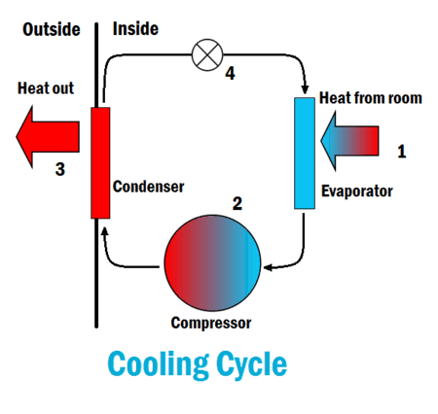

Fig no 7.4: Cooling cycle of heat pump

**Efficiency of Heat Pump:**

An Air Source **Heat Pump** (ASHP) will typically produce around 3kW thermal energy for every 1kW of electrical energy consumed, giving an effective “**efficiency**” of 300%. It is thermodynamically impossible to have an **efficiency** of more than 100%, as this implies that more energy is being produced than is being put in.

**Applications of Heat Pump:**

* Domestic hot water ,Space Heating ,Cooling for Bungalows and Apartments.
* Sanitary hot water for Hotels ,Hospitals , Leisure center
* Commercial heating and cooling or Buildings ,Complexes
* Constant hot water for swimming pool
* Constant temperature for green house
* High temperature heat pumps for drying and Steaming

**Calculations:**

**For Summer Season:**

|  |  |
| --- | --- |
| **Part Name** | **Value** |
| Compressor Outlet | 34.2 |
| Condenser Inlet | 22.4 |
| Condenser Mid | 20.5 |
| Condenser Outlet | 20.7 |
| Expansion Valve | -8.0 |
| Liquid Receiver | 20.4 |
| Evaporator Inlet | -10.5 |
| Evaporator Mid | 18.2 |
| Evaporator Outlet | 17.6 |
| Compressor Inlet | 20.6 |

**For Winter Season:**

|  |  |
| --- | --- |
| **Part Name** | **Value** |
| Condenser Mid | 23.6 |
| Condenser Inlet | 22.3 |
| Compressor Outlet | 24.7 |
| Condenser Outlet | 23.8 |
| Evaporator Inlet | -4.6 |
| Liquid Receiver | 23.0 |
| Evaporator Mid | 15.7 |
| Expansion Valve | -2.7 |
| Evaporator Outlet | 18.2 |
| Compressor Inlet | 16.6 |

**PV Diagram:**

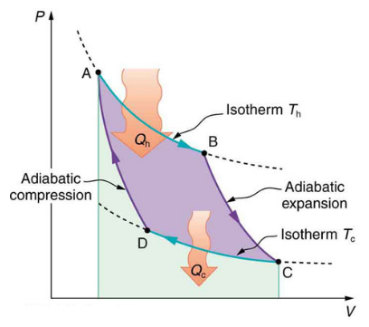

**TS Diagram:**

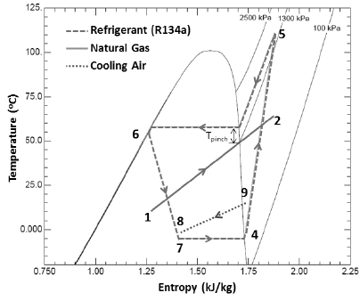

**Application:**

Heat Pumps can be used in several industrial processes. Industrial plants have both waste heat flows and heat consumers. Waste heat flows are for example: waste water, hot humid air, condenser heat from refrigeration systems, etc. Heat consumers are process water, central heating systems, blanchers, dryers, etc